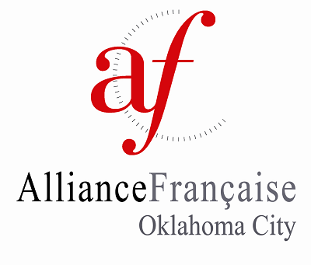 | 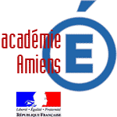

FRANCO-AMERICAN FELLOWS PROGRAM

APPLICATION FORM 2023-2024
By signing this application form you agree to have read and understood the guidelines which accompany this form.

All information must be typed and submitted electronically. You will need to save the document to your computer, and then attach in an e-mail to the address provided. Please note there is a separate document for the Teacher Nomination form for your teacher’s convenience.

PERSONAL DETAILS
Name: |  |  |  |  |  | Grade:
Date of Birth: |  | Are you a U.S. Citizen?:
Address:
(street) |  | (city) |  |  | (state) |  | (zip)
Home phone: |  | Cell:
Personal e-mail: |  | Parent e-mail:
Emergency contact details in US:
Name: |  | Relationship to you:
Home phone: | Work phone: |  |  | Cell:
Please describe your language learning experience (languages, levels studied, etc.):

Please describe any travel experience:

SCHOOL DETAILS
Name of school:
Address:
(street) |  | (city) |  |  | (state) |  | (zip)
Phone: |  |  | Fax:
Principal’s Name: |  |  | Principal’s e-mail:

PROJECT OUTLINE
Please complete the information below. You may use additional space if necessary.
Title of Project:

Project aims and brief summary (What are your reasons for undertaking the project? What do you hope to achieve or discover on its completion?):

Related subject areas (How does your project relate to your studies or a specific piece of coursework?):

Preparation before the visit (List steps you can take before your visit that will make your project work feasible?):

Project activities during the visit, both in and out of school (How will you spend your time and how will this benefit your project?):

Research methods (e.g. questionnaires, interviews, field visits, etc.) (Be sure to address why you need to travel to France to undertake your research):

Please also provide evidence of how you plan to disseminate your project and share your experience with fellow students / teachers at your school / your community.

Applications available online, starting Monday, September 12, 2023, at afdokc.org.

DATES OF VISIT

Date of visit: March 16- March 30, 2024

IMPORTANT DATES

Student application must be emailed by Friday, October 20, 2023.

- Finalists announced Friday, November 3, 2023.

- Finalists interviewed Wednesday, November 8, 2023. Location TBA.

- 2024 Eleanor Kirkpatrick Franco-American Fellows announced Monday, November 20, 2023.

- Fellows’ letters of acceptance and intent completed and returned by Monday, November 27, 2023.

- Please apply for your passport by December 1, 2023, if you do not already have one. It is the only way to guarantee having it in time for travel. There is a possibility we will need to apply for an ETIAS authorisation. Details TBD.

- Pre-departure meeting Thursday, February 15, 2024

- Fellows Reception, tentative date, Sunday, February 25, 2024

- Program dates: March 16- March 30, 2024

- Presentation of projects: Saturday, May 4, 2024

- Posting of Project Summary to AFdOKC website: May 2024 (TBD)

Please print this page before obtaining signatures. Remember to scan it and include it with your application

STUDENT AGREEMENT

Data Protection Notice

L’Alliance Française d’Oklahoma City will use the information you provide for the purpose of administering and evaluating the Franco-American Fellows Program. We may also disclose some information to third parties to promote the program and encourage networking. Examples include the local press, the Oklahoma State Department of Education, and other interested parties.

I confirm by my signature below that all the details submitted are, to the best of my knowledge, correct and that the project proposal is my own work. I have read and I agree to the terms as set out in the application guidelines.

________________________________________ ____________________________________

Signature of Applicant Date

PARENTAL CONSENT

I confirm that I have read and fully support the application of my son / daughter and agree to his/her study visit to France, if selected.

________________________________________ ______________________________________
Signature of Parent / Guardian Date

PRINCIPAL CONSENT

I confirm that I have read and fully support the application of ____________________________,
and agree to his/her study visit to France if selected.

______________________________________ ____________________________________
Signature of Principal Date

When completed and signed please give your application to your French teacher so that he/she may complete the nomination form. (Be sure to give your teacher this application to allow sufficient time to complete and return all materials by the deadline.)

Return all forms to:
Franco-American Fellows Committee
Fafellows.afdokc@gmail.com

TEACHER’S NOMINATION FORM

French teachers in Central Oklahoma may nominate two (2) current students, from each institution in which they teach, who meet the application criteria. Homeschool students are encouraged to apply.

Name of Student:

Name of French Teacher: Current French Level

E-mail(s):

Partner School in France (If applicable):

Please provide a reference for the applicant as indicated, including comments about the following:

(1) proposed project and relevance to studies, (2) academic achievements, (3) language skills, (4) the ability to work independently, (5) initiative, (6) reliability, (7) social and interpersonal skills, (8) organisational skills

Please also indicate in what ways you can support the above applicant before, during, and after his/her participation in the Franco-American Fellows Program.

Please email your letter to fafellows.afdokc@gmail.com by October 20, 2023.

You may attach one additional sheet to this reference form if necessary.

______________________________________ _______________________________
Teacher Signature Date

Application Checklist

- Application Form
- Project Outline
- Student Agreement & Consent Form
- Teacher’s Nomination Form

All documents must be submitted electronically. Please email to:

Franco-American Fellows Committee
Fafellows.afdokc@gmail.com

405-760-4295

