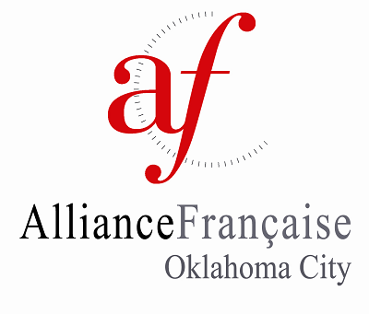 | 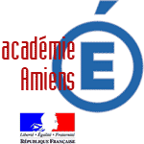

Eleanor Kirkpatrick Franco-American Fellows Program

Application for Accompanying Adult
The Eleanor Kirkpatrick Franco-American Fellows program, a joint project between l’Alliance Française d’Oklahoma City and the French Education Ministry with the support of the Oklahoma State Department of Education, provides funds for a select group of central Oklahoma students and at least one adult to participate in a two-week research project while staying with French families and attending a French school. The grant covers the costs of airline travel, lodging, and meals, and is made possible through a grant from the Kirkpatrick Family Fund.
L’Alliance Française d'Oklahoma City is accepting applicants to accompany the group of students on their research trip to France from March 16- 30, 2024. Applicants must be from central Oklahoma, fluent in French, and a member of l’Alliance Française d’Oklahoma City. See www.afdokc.org for information on how to join.

Please complete the attached application and submit electronically to:
Franco-American Fellows Committee
Fafellows.afdokc@gmail.com
(405) 760-4295

Eleanor Kirkpatrick Franco-American Fellows Program

Application for Accompanying Adult

You must type directly on this document. Please remember to save to your computer before submitting electronically.

1. PERSONAL DETAILS
Name: |  |  |  |  | Date of Birth:
Address:
 |  | Street |  | City, State |  | Zip Code
Phone: |  |  |  | e-mail:
 | home |  | cell
Passport Number: |  |  |  | Nationality:
Are you a member of l’Alliance Française d’Oklahoma City? |  |  |  |  |  |  | ☐ Yes | ☐ No
2. EMERGENCY CONTACT IN THE U.S.
Name: |  |  |  | Relationship to you:
Phone: |  |  |  | e-mail:
 | home |  | cell

Please enter your responses. You may use additional space if necessary.

3. EXPERIENCE
Please comment on your language experience:

Please comment on your travel experience:

How would you rate your French according to the ACTFL Proficiency Guidelines?

4. PERSONAL STAEMENTS
- Describe your experience working with 16-22 year olds.

- Have you accompanied students on an overseas trip before? Please explain.

- How could you help strengthen the Oklahoma-Amiens partnership while you are in France?

- What personal goals would this opportunity help you achieve?

- The trip is scheduled for March 16-30, 2024. Do you have any conflicts that would prevent you from going? Are you able to attain authorization from your school principal to miss a week of classes?

5. REFERENCES
Please provide contact information for 2 professional references
Name: |  |  | Title:
Phone: |  |  | e-mail:
 | home | cell
Name: |  |  | Title:
Phone: |  |  | e-mail:
 | home | cell

6. EXPECTATIONS
Accompanying a group of students overseas is an enormous responsibility. The chaperone is responsible for ensuring the students safety and well-being at all times. The chaperone must recognize that the purpose of this trip is student research. This is not a personal trip, nor is it a student travel tour.

The chaperone is expected to:
- Attend all Fellows-related events sponsored by l’AFdOKC (i.e., pre-departure meeting, send-off reception and presentation of research findings)
- Communicate with the host school and mentor teacher in advance of the program dates
- Either make arrangements for an international cell phone plan or purchase a SIM card in France to allow communication with the Fellows and the Fellows Chair while in France. (Note that wifi is not available in all places)
- Ensure the students spend at least 50% of their school day in classes. (Total time spent in class should equal at least 5 full school days)
- Ensure the students are working on their research when not in class
- Facilitate student research, including site visits, translation, and interviews when necessary
- Remain with students until all have been picked up by host families/host student or other responsible adult
- Respect the host families, communicate plans in advance, and adhere to predetermined meeting times
- Schedule personal meetings and activities outside of the school day
- Coordinate with Fellows chair for the presentation of research projects to the Alliance Française, and ensure the presentations are available and compatible with the AV equipment.

I have read and understand the expectations of the Fellows Chaperone and if selected agree to adhere to these guidelines. (please initial)

7. FUNDING
- L’AFdOKC will purchase round-trip airfare and travel insurance for the chaperone. Housing and some meals will be provided by a local host family.
- In addition, l’AFdOKC will reimburse the chaperone for research-related expenses for the group, including local travel and entry fees, up to $500. Receipts must be submitted within two weeks of the conclusion of the program for timely reimbursement.
- At no time should the students be expected to cover the chaperone’s expenses.
- This should not be considered an all-expenses paid trip. The chaperone should expect to spend
some of his/her personal funds for meals and other expenses.

I have read the explanation of funding and understand that if selected, I will be reimbursed for up to $500 for group expenses upon return. (please initial)
9. IMPORTANT DATES
- Application must be received by Friday, October 20, 2023.
- Accompanying Adult selected by Friday, November 3, 2023.
- Welcome reception and send-off for Fellows on Sunday, February 25, 2024.
- Student Finalists interviewed on Wednesday, November 8, 2023. (if selected, you may be asked to serve on the interview panel)
- Pre-departure meeting, Thursday, February 15, 2024
- Dates of visit: March 16-30, 2024

Please email your completed application by Friday, October 20, 2023 to:
Franco-American Fellows Committee
Fafellows.afdokc@gmail.com
(405) 760-4295

